**Coding Assessment-SQL**

CREATE DATABASE burger_bash;

USE burger_bash;

CREATE TABLE burger_names (

burger_id INT PRIMARY KEY,

burger_name VARCHAR(100)

);

INSERT INTO burger_names VALUES

(1, 'Beef Burger'),

(2, 'Vegetarian Burger'),

(3, 'Chicken Burger'),

(4, 'Meatlovers Burger');

CREATE TABLE burger_runner (

runner_id INT PRIMARY KEY,

registration_date DATE

);

INSERT INTO burger_runner VALUES

(1, '2022-01-01'),

(2, '2022-01-08'),

(3, '2022-01-15');

--DROP TABLE IF EXISTS runner_orders;

--DROP TABLE IF EXISTS customer_orders;

CREATE TABLE customer_orders (

order_id INT,

customer_id INT,

burger_id INT,

exclusions VARCHAR(100),

extras VARCHAR(100),

order_time DATETIME

);

CREATE TABLE runner_orders (

order_id INT,

runner_id INT,

pickup_time DATETIME,

distance VARCHAR(20),

duration VARCHAR(20),

cancellation VARCHAR(20)

);

INSERT INTO customer_orders (order_id, customer_id, burger_id, exclusions, extras, order_time) VALUES

(101, 1, 1, NULL, 'Cheese', '2022-01-05 12:00:00'),

(102, 1, 2, 'Onion', NULL, '2022-01-05 13:10:00'),

(103, 2, 2, NULL, NULL, '2022-01-06 14:05:00'),

(104, 3, 4, NULL, 'Bacon', '2022-01-07 12:05:00'),

(105, 2, 3, 'Lettuce', NULL, '2022-01-08 11:30:00'),

(106, 1, 4, NULL, NULL, '2022-01-08 14:23:00');

INSERT INTO runner_orders (order_id, runner_id, pickup_time, distance, duration, cancellation) VALUES

(101, 1, '2022-01-05 12:30:00', '5km', '30min', NULL),

(102, 2, '2022-01-05 13:40:00', '3km', '20min', NULL),

(103, 1, '2022-01-06 14:31:00', '6km', '33min', 'Cancelled'),

(104, 3, '2022-01-07 12:32:00', '4km', '25min', NULL),

(105, 2, NULL, NULL, NULL, 'Cancelled'),

(106, 2, '2022-01-08 14:56:00', '2km', '10min', NULL);

SELECT COUNT(*) AS total_burgers_ordered FROM customer_orders;

SELECT COUNT(DISTINCT order_id) AS unique_customer_orders FROM customer_orders;

SELECT runner_id, COUNT(*) AS successful_orders

FROM runner_orders

WHERE cancellation IS NULL

GROUP BY runner_id;

SELECT b.burger_name, COUNT(*) AS burgers_delivered

FROM customer_orders c

JOIN runner_orders r ON c.order_id = r.order_id

JOIN burger_names b ON c.burger_id = b.burger_id

WHERE r.cancellation IS NULL

GROUP BY b.burger_name;

SELECT customer_id,

SUM(CASE WHEN burger_id = 2 THEN 1 ELSE 0 END) AS Vegetarian_Burger,

SUM(CASE WHEN burger_id = 4 THEN 1 ELSE 0 END) AS Meatlovers_Burger

FROM customer_orders

GROUP BY customer_id;

**Using Joins and Aggregate Functions**

**-- 1. List all delivered burger orders along with burger names and runner IDs**

SELECT co.order_id, b.burger_name, ro.runner_id, ro.pickup_time

FROM customer_orders co

JOIN runner_orders ro ON co.order_id = ro.order_id

JOIN burger_names b ON co.burger_id = b.burger_id

WHERE ro.cancellation IS NULL;

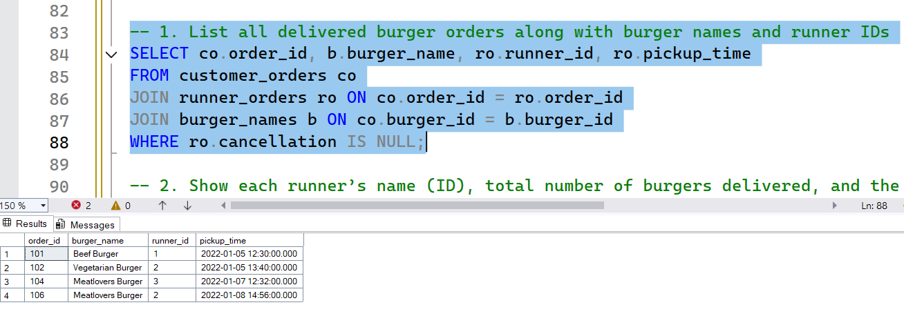

**-- 2.** **Show each runner’s name (ID), total number of burgers delivered, and the burger types they've delivered**

SELECT ro.runner_id, b.burger_name, COUNT(*) AS total_deliveries

FROM runner_orders ro

JOIN customer_orders co ON ro.order_id = co.order_id

JOIN burger_names b ON co.burger_id = b.burger_id

WHERE ro.cancellation IS NULL

GROUP BY ro.runner_id, b.burger_name

ORDER BY ro.runner_id;

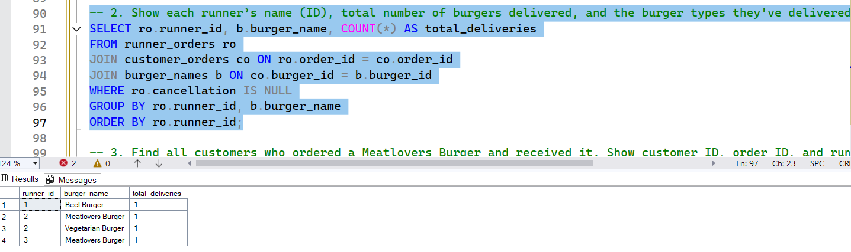

**-- 3. Find all customers who ordered a Meatlovers Burger and received it. Show customer ID, order ID, and runner.**

SELECT co.customer_id, co.order_id, ro.runner_id

FROM customer_orders co

JOIN runner_orders ro ON co.order_id = ro.order_id

WHERE ro.cancellation IS NULL

AND co.burger_id = (

SELECT burger_id FROM burger_names WHERE burger_name = 'Meatlovers Burger');

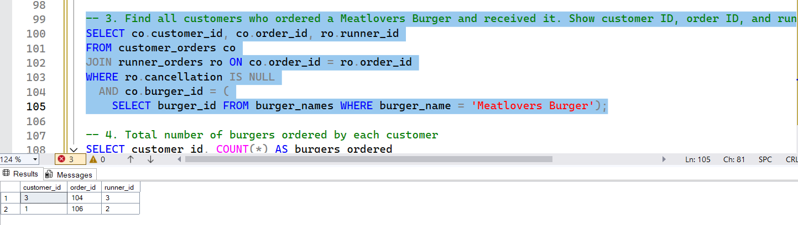

**-- 4. Total number of burgers ordered by each customer**

SELECT customer_id, COUNT(*) AS burgers_ordered

FROM customer_orders

GROUP BY customer_id

ORDER BY burgers_ordered DESC;

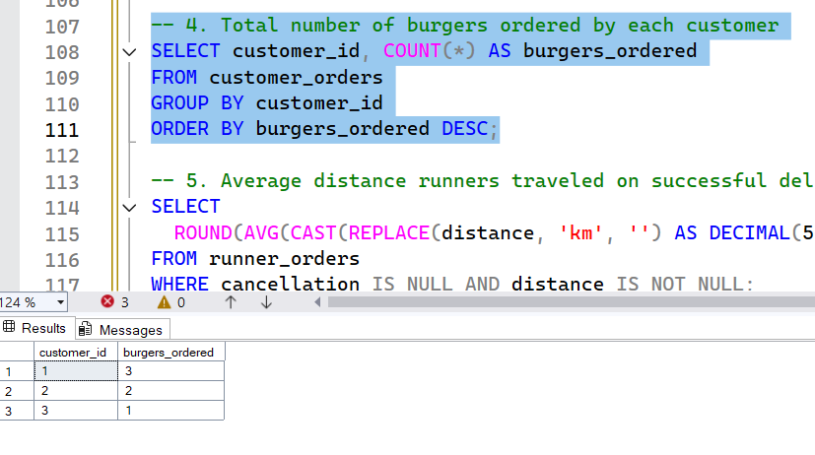

**-- 5. Average distance runners travelled on successful deliveries**

SELECT

ROUND(AVG(CAST(REPLACE(distance, 'km', '') AS DECIMAL(5,2))), 2) AS average_distance_km

FROM runner_orders

WHERE cancellation IS NULL AND distance IS NOT NULL;

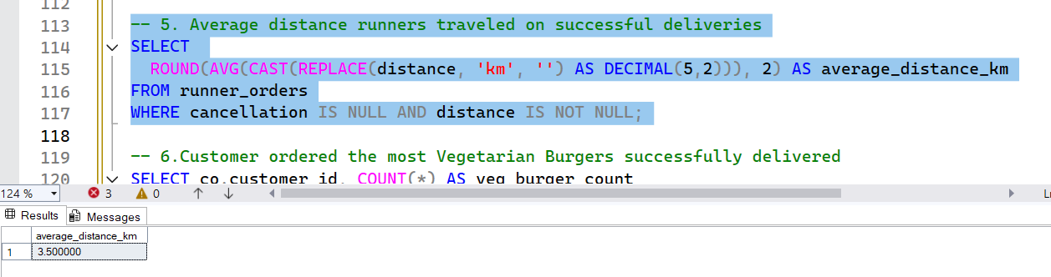

**-- 6. Customer ordered the most Vegetarian Burgers successfully delivered**

SELECT co.customer_id, COUNT(*) AS veg_burger_count

FROM customer_orders co

JOIN runner_orders ro ON co.order_id = ro.order_id

WHERE ro.cancellation IS NULL

AND co.burger_id = (

SELECT burger_id FROM burger_names WHERE burger_name = 'Vegetarian Burger' )

GROUP BY co.customer_id

ORDER BY veg_burger_count DESC;

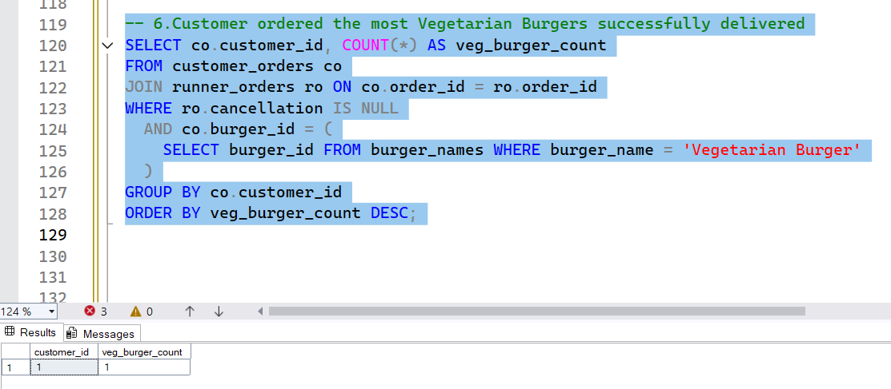

**Submitted by**

Siva Balan T